**Keying chart for Gurmukhi WinScript**

|  |  |  |  |  |  |  |
| --- | --- | --- | --- | --- | --- | --- |
| ਅ | ਆ | ਇ | ਈ | ਉ | ਊ |  |
| a | A | i | I | u | U |  |
| ਏ | ਐ | ਓ | ਔ | ਅਂ | ਅਁ | ਅ: |
| e | E | o | O | aM | aS | a: |
| ਕ | ਕਾ | ਕਿ | ਕੀ | ਕੁ | ਕੂ |  |
| k | kA | ki | kI | ku | kU |  |
| ਕੇ | ਕੈ | ਕੋ | ਕੌ | ਕਂ | ਕਁ | ਕ: |
| ke | kE | ko | kO | kM | kS | k: |
| ਕ | ਖ | ਗ | ਘ | ਙ | ਕ਼ | ਖ਼ |
| k | K | g | G | W | kq | Kq |
| ਚ | ਛ | ਜ | ਝ | ਞ | ਨ੍ਯ | ਜ਼ |
| c | C | j | J | w | nxy | jq |
| ਟ | ਠ | ਡ | ਢ | ਣ | ਡ਼ | ਟ੍ਟ |
| f | F | [ | { | N | [q | fxf |
| ਤ | ਥ | ਦ | ਧ | ਨ | ਤ੍ਤ | ਦ੍ਵ |
| t | T | d | D | n | txt | dxv |
| ਪ | ਫ | ਬ | ਭ | ਮ | ਦ੍ਦ | ਬ੍ਬ |
| p | P | b | B | m | pxp | bxb |
| ਯ | ਰ | ਲ | ਵ | ਰੁ | ਰੂ | ਰ੍ਕ |
| y | r | l | v | ru | rU | rxk |
| ਸ਼ | ਸ | ਹ |  | ਟ੍ਰ | ਜ੍ਞ | ਕ੍ਰ |
| z | s | h |  | txr | jxw | kxr |
| ਫ਼ |  |  |  |  |  |  |
| Pq |  |  |  |  |  |  |

# Conjunct characters:

A simple conjunct is typed by pressing x between the consonants. e.g. n x n 🡪 ਨ੍ਨ

A joined conjunct is typed by pressing x x between the consonants. e.g. n x x n 🡪 ਨ੍‍ਨ

A non-joined conjunct is typed by pressing shift x between the consonants. e.g. n shift x n 🡪 ਨ੍‌ਨ

*Alternative*: To change one type of conjunct to another, press the backtick ` key after it.

e.g. ਨ੍ਨ ` 🡪 ਨ੍‌ਨ

# Dependent/Independent Vowels:

The keyboard will normally produce independent vowels, except after consonants, when it will produce independent vowels.

e.g. i 🡪 ਇ g i 🡪 ਗਿ

To force an independent vowel after a consonant, press a after the consonant.

e.g. g a i 🡪 ਗਇ

*Alternative*: To change one type of vowel to the other, press the backtick ` key after it.

e.g. ਗਿ ` 🡪 ਗਇ ` 🡪 ਗਿ

Alternate forms:

In addition to altering conjuncts and vowels, the backtick ` key can produce changes like these:

e.g. ੪ ` 🡪 4 toggle digits: script ⬄ roman

# Alternate characters:

Various related characters can be obtained by pressing the same key again without pausing.

e.g. n 🡪 ਨ n 🡪 ਣ n 🡪 ਞ n 🡪 ਙ

If you actually want a sequence of the character, either pause or press a in between.

e.g. n n 🡪 ਣ n a n 🡪 ਨਨ

# Smart Quotes:

Press the single quote ' or double quote " key again to switch between left and right smart quotes. e.g. “ " 🡪 ”

# Brackets:

Press the open or close parenthesis key up to 3 more times to obtain alternative forms of bracketing.

e.g. ( ( 🡪 [ ( 🡪 { ( 🡪 ⌊

# Note to Advanced Users:

If you need an independent ZWJ or ZWNJ character (very rare), type space followed by x or shift x respectively.

**Gurmukhi WinScript Layout**

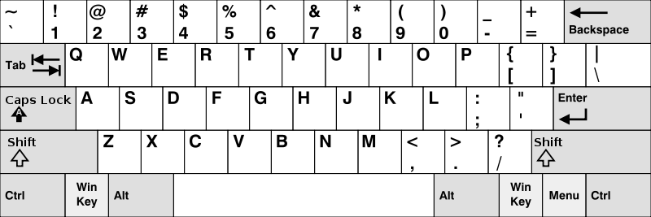

**੧**

**੦**

**੯**

**੮**

**੭**

**੬**

**੫**

**੪**

**੩**

**੨**

**ਊ**

**ਢ**

**ਡ**

**ਫ**

**ਪ**

**ਔ**

**ਥ**

**ਐ**

**ਙ**

**ਈ**

**઼**

**ਓ**

**ਉ**

**ਆ**

**୍**

**ਅ**

**ਯ**

**ਤ**

**ਰ**

**ਏ**

**ਞ**

**ਇ**

**ਲ**

**ਧ**

**ਦ**

**ਖ**

**ਕ**

**ਝ**

**ਜ**

**ਃ**

**ਹ**

**ਘ**

**ਗ**

**ਠ**

**ਟ**

**ઁ**

**ਸ**

**ં**

**ਣ**

**ਭ**

**ਛ**

**ਮ**

**ਨ**

**ਬ**

**ਵ**

**ਚ**

**ਸ਼**